Hypothesis testing

How to?

Step 1:

List:

List these parameters.

$$n$$: number of samples

$$bar\left(X\right)$$: observed value of mean in sample $$X$$.

$$S$$: estimated standard deviation in sample $$X$$.

$$mu_{0}$$: expected mean in sample X. (Which we want to find)

$$alpha$$: significance level.

Step 2:

Make:

Make hypothesis. Generating conditions for hypothesis.

$$H_{0}$$ as accepted condition.

$$H_{1}$$ as rejected condition.

When the result is in $$H_{0}$$, the hypothesis is accepted.

Otherwise, the hypothesis is NOT accepted (I.e. rejected)

NOTICE

NOTICE that conditions contains equal sign must be placed in $$H_{0}$$.

Step 3:

Statistic evaluation:

Select what statistic value we should use for evaluation.

Step 4:

Statistic model:

Select a statistic model for hypothesis according to number of sample etc.

Step 5:

Hypothesis testing:

Find type of hypothesis testing we need according to conditions listed in Step 2, by the way, list its critical.

It is always one of following:

Lower-tail test

Upper-tail test

Two-tail test

For more details, see my note (Z值法.docx)

Step 6:

Critical point:

According to significance level, look at distribution table, get critical point. (It may be $$Z_{alpha}$$ or $$Z_{\frac{alpha}{2}}$$ according to type of hypothesis testing)

Moreover, draw a graph for visual computation.

Step 7:

Observed value:

Evaluate observed value in hypothesis.

Step 8:

Check condition:

I.e. Compare observed value in hypothesis to critical.

NOTICE

NOTICE that

Iff hypthesis statistic is in condition, it accepts.

Otherwise, it does NOT accepts (I.e. it rejects).

Type Error

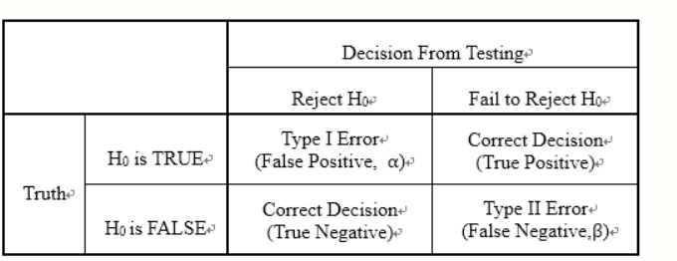

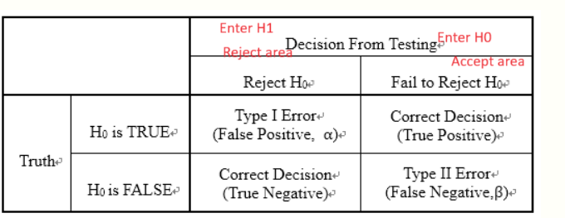

Examples

Example 1

From example 11.2 in p.278 in textbook CH11.

Step 1:

We can know that

$$n$$ = 36

$$bar\left(X\right)$$ = 7.8h

$$S$$ = 2.7h

$$mu_{0}$$ = 10h

$$alpha$$ = 0.05

Step 2:

Make hypothesis.

$$H_{0}$$: $$mu≥10$$ (accept)

$$H_{1}$$: $$mu<10$$ (reject)

Step 3:

We use $$bar\left(X\right)$$ to evaluate it.

Step 4:

Select the distribution.

Since $$n==36≥30$$, it is consider as big sample. Thus, it approximates to normal

distribution.

(for more details about definition of big data and approximation to normal distribution , see textbook)

Here, we use standardized normal distribution to evaluate it.

Step 5:

Since $$H_{1}$$ only contain $$<$$ sign, we have to adopt lower-tail test.

Step 6:

Get critical.

With significance level $$alpha$$ = 0.05, look at standardized normal distribution table, we can get that

$$Z_{0.05}$$ = $$1.645$$

=>

$$−Z_{0.05}$$ = $$−1.645$$

(since it is symmetric to y-axis in standardized normal distribution)

Step 7:

Evaluate the observed value in hypothesis.

$$Z$$

= $$\frac{\left[bar\left(X\right)−mu_{0}\right]}{\frac{S}{n^{\frac{1}{2}}}}$$

NOTICE

NOTICE that we adopt the formula

$$\frac{\left[bar\left(X\right)−mu_{0}\right]}{\frac{S}{n^{\frac{1}{2}}}}$$

rather than

$$\frac{\left[bar\left(X\right)−mu_{0}\right]}{\frac{std\left(X\right)}{n^{\frac{1}{2}}}}$$

because we don’t know what actual standard deviation in original research (the question does NOT offer it), we have to use observed standard deviation in sample space $$S$$.

( for more details, see my note Formula of Variance analysis.docx )

$$Z$$

= $$\frac{\left[bar\left(X\right)−mu_{0}\right]}{\frac{S}{n^{\frac{1}{2}}}}$$

= $$\frac{\left[7.8−10\right]}{\frac{2.7}{{36}^{\frac{1}{2}}}}$$

= $$−4.89$$

Step 8:

Compare observed value in hypothesis to critical.

observed value in hypothesis : $$Z$$ = - 4.89

critical : $$Z_{alpha}$$ = -1.645

Thus, it falls to reject area.

That is, with siginificance level $$alpha$$ == 0.05, we know that

It spends less than 10 hours on sleeping for college student in Taiwan.

Example 2

From example 11.1 in p.274 in textbook CH11.

Step 1:

We know that

$$mu_{0}$$ = 3kg

$$bar\left(X\right)$$ = 2.95kg

$$S$$ = 0.38kg

$$n$$ = 49

$$alpha$$ = 0.05

Step 2:

Make hypothesis.

$$H_{0}$$: $$mu≥3$$ (accept area)

$$H_{1}$$: $$mu<3$$ (reject area)

Step 3:

Value of mean in sample is a good estimation of value of mean in population.

Thus, we use value of mean in sample.

Step 4:

Select the distribution.

Since $$n==49≥30$$, it is considered as a big sample.

According to CLT, value of mean in sample approximates to the value of mean in sample with normal distribution.

Thus, we use normal distribution.

Step 5:

Since $$H_{1}$$ only contain $$<$$ sign, we have to adopt the lower-tail test.

Step 6:

Get critical.

With significance level $$alpha$$ == 0.05, look at standardized normal distribution table,

$$Z_{0.05}$$ = $$1.645$$

=>

$$−Z_{0.05}=−1.645$$

(since it is symmetric to y-axis in standardized normal distribution)

Step 7:

Evaluate observed value in hypothesis.

$$bar{\left(X\right)}^{⋅}$$

= $$mu−Z_{0.05}S_{bar\left(X\right)}$$

= $$3−1.645⋅0.054$$

= $$2.911$$

Step 8:

Compare observed value in hypothesis to critical.

$$bar{\left(X\right)}^{⋅}$$ = 2.911

Critical = $$2.95$$

=>

$$bar{\left(X\right)}^{⋅}<$$ Critical

Thus, it falls to accept area. That is, we can know that

台新company does NOT lie to customers.

Example 3

From example 11.4 in p.280 textbook CH11.

Step 1:

We know that

$$n$$ = 100

$$bar\left(X\right)$$ = 80.21

$$std\left(X\right)$$ = 4

$$mu_{0}$$ = 80.0

$$alpha$$ = 0.01

Step 2:

Make hypothesis.

$$H_{0}$$: $$mu$$ == 80.0

$$H_{1}$$: $$mu !=$$ 80.0

Step 3:

Use $$bar\left(X\right)$$.

Step 4:

Since $$n=100≥30$$, it can be considered as a big sample.

Thus, it approxiates normal distribution.

Step 5:

Since $$H_{1}$$ only contain $$!=$$ sign, we have to use two-tail test.

Step 6:

Get critical.

With $$alpha$$ == 0.01 (here $$\frac{alpha}{2}$$ == 0.005 ), look at standardized normal distribution, the uppper critical:

$$Z_{0.005}$$ = 2.575

While lower critical:

$$−Z_{0.005}$$ = -2.575

(since it is symmetric to y-axis in standardized normal distribution)

Step 7:

Evaluate observed value in hypothesis.

$$Z$$

= $$\frac{\left[bar\left(X\right)−mu_{0}\right]}{\frac{std\left(X\right)}{n^{\frac{1}{2}}}}$$

= $$\frac{\left(80.21−80\right)}{\frac{4}{{100}^{\frac{1}{2}}}}$$

= 0.525

Step 8:

Compare observed value in hypothesis to critical.

Observed value in hypothesis:

$$Z$$ = 0.525

Upper critical:

$$Z_{0.005}$$ = 2.575

Lower critical:

$$−Z_{0.005}$$ = -2.575

=>

$$−Z_{0.005}<observed value<Z_{0.005}$$

Thus, it falls in accept area.

That is, in significance level $$alpha==0.01$$, the mean of life for Taiwanese citizen is 80 age.

Ref

From textbook CH 11 ( see GitHub ).

From pixnet.

[假設檢定(Hypothesis Testing) @ 有勁的基因資訊 :: 痞客邦 :: (pixnet.net)](https://yourgene.pixnet.net/blog/post/116944086-%E5%81%87%E8%A8%AD%E6%AA%A2%E5%AE%9A(hypothesis-test)

From Wiki.

[Statistical hypothesis testing - Wikipedia](https://en.wikipedia.org/wiki/Statistical_hypothesis_testing)